REVITALIZATION DISTRICT
PO Box 388, Kamiah ID 83536 208-935-2672
PERMIT #
PLEASE NOTE: OWNER IS RESPONSIBLE FOR OBTAINING BUILDING PERMIT IF CONTRACTOR IS NOT LICENSED.

SITE ADDRESS _________________________________
SITE LEGAL DESCRIPTION ___________________________________________________________________
PROPERTY OWNER’S NAME __________________________________________________________________
Address _______________________________________________________Phone _________________

Contractor_________________________ License # ____________________ Phone # _________________
Designer __________________________ License # ____________________ Phone # _________________
Engineer__________________________ License # ____________________ Phone # _________________

WORK IS: Addition ____ Alteration ____ Repair ____ Re-roof ____ Painting _____

GROUND SNOW LOAD = 30PSF WINDSPEED=90MPH SEISMIC ZONE: C FLOOR LOAD = 40 PSF
Type of construction ____________ Occupancy Group ______________ Building Area _______________
Number of stories _______ Number of Units/Sections _______ Project Valuation ___________

This permit becomes null and void if work is not completed within 180 days, or if construction work is suspended or abandoned for a period of 180 days at anytime after work has commenced. Construction needs to be substantially complete within one (1) year from issue date of permit, at which time a one 180-days-extension can be granted by the building official.
A set of plans, drawn to scale, must accompany this application and must define:
type of construction, designs, changes, alterations, and/or remodeling.
All exterior colors must be Victorian in hue and must be accurately portrayed.

The US Environmental Protection Agency requires that renovation, repair, and painting projects that disturb
lead-based paint in pre-1978 homes, childcare facilities and schools must be performed by an EPA Certified Renovator working for an EPA Certified Firm and specific work practices must be implemented to prevent lead contamination. More information is available at 1-800-424-LEAD (5323) or http://www2.epa.gov/lead.
I hereby certify that I have read and examined this application and know the same to be true and correct. All provisions of the law and ordinances governing this type of work will be complied with whether specified herein or not. The granting of this permit or approval of plans does not presume to give authority to violate or cancel the provisions of any other state of local law regulating construction or performance of construction. All changes from approved plans must be submitted and approved prior to start of that change.

I understand that all buildings within the City of Kamiah Revitalization District
must have an exterior design that conforms to a Western/Victorian theme.
All exterior architecture, colors of paint, and signage
must be approved by City of Kamiah Planning and Zoning Board.
(See Attachment “C” City of Kamiah)

APPLICANT’S SIGNATURE _______________________________ Date _________________
Print applicant’s name ______________________________ COMPANY ____________________________
APPLICANT IS: Owner _____ Contractor/Builder _____ Owner’s agent ______ Other _______

OFFICE USE ONLY Date received ________ Application accepted by ______________
Approved for issuance by ____________ Plan reviewed by _________________
Plan review fee $_____________ Permit fee $______________ Total $_____________
_________________________________________________________________________________________
INSPECTION Pre-construction meeting date __________ With whom ________________

Footings __________________ Foundation __________________ Framing ________________ Braced wall _______________
Insulation _________________ Venting __________________ Drywall ______________ Final ____________________
Special ____________________________________ Decks ____________________ Slabs_____________

BUILDING PROJECT COMPLETED: ________ DATE__________ BUILDING CODE INSPECTOR ____________________

24 hour notice for all inspections. It is your responsibility to call for ALL required inspections.

WHEN APPROVED THIS IS YOUR PERMIT Based on 2003 “I” Codes
APPROVED PLANS AND PERMIT MUST BE ON THE SITE FOR ALL INSPECTIONS.

EACH PAINT COMPANY WILL HAVE ITS OWN VERSION OF VICTORIAN COLORS.
THE FOLLOWING ARE SAMPLES FOUND ON-LINE.
VICTORIAN COLORS ARE EARTHY, DARKER IN TONES.

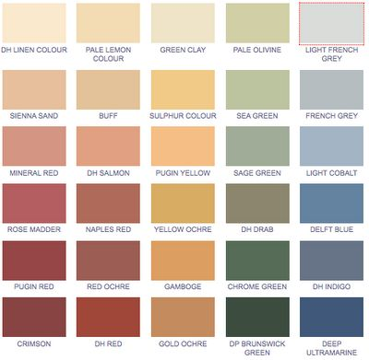

A SELECTION OF 3 COLOR VICTORIAN COMBINATION IS A MINIMUM REQUIREMENT.
The following is an example of three color combination

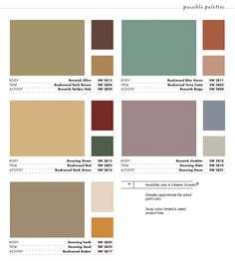

IN THE KAMIAH REVITLIZATION ZONE
ALL EXTERIOR COLORS MUST BE VICTORIAN COLOR IN HUE
AND APPROVED BY KAMIAH PLANNING AND ZONING.

